

PROGRAMME | MASTER OF COMPUTER APPLICATIONS (MCA)
SEMESTER | I
COURSE CODE & NAME | DCA6108 DISCREATE MATHEMATICS AND GRAPH THEORY

Section A
Multiple Choice Questions (2 Marks each)
[Please answer all the questions]

- If $A=a,b,c$ and $R=\left(a,a\right),\left(a,b\right),\left(b,c\right),\left(b,b\right),\left(c,c\right),\left(c,a\right)$is a binary relation on A, then which one of the following is correct?
  - $R$ is reflexive and symmetric, but not transitive
  - $R$ is reflexive and transitive, but not symmetric
  - $R$ is reflexive but neither symmetric nor transitive
  - $R$ is reflexive, symmetric and transitive

- If $A$ and $B$ are subsets of a set $X$, then what is $A\bigcap{\left(X-B\right)}\bigcup{B}$ equal to?
  - $A∪B$
  - $A∩B$
  - $A$
  - $B$

- If $A$ and $B$ are disjoint sets, then $A∩\left(A^{'}∪B\right)$ is equal to which one of the following
  - $∅$
  - $A$
  - $A∪B$
  - $A-B^{'}$

- The function $f:R→R$ defined by $f\left(x\right)={\left(x_{2}+1\right)}^{35}$ for all $xϵR$ is
- One-one but not onto
- Onto but not one-one
- Neither one-one not onto
- Both one-one and onto
- Given matrix [A]=$\left[\begin{matrix}4 & 2 & 1 \\ 6 & 3 & 4 \\ 2 & 1 & 0\end{matrix} \begin{matrix}3 \\ 7 \\ 1\end{matrix}\right]$, the rank of the matrix is
  - 2
  - 3
  - 2
  - 1

- A biased coin with probability $p, 0<p<1$ of heads is tossed until a head appears for the first time. If the probability that the number of tossed required is even, $\frac{2}{5}$ then $p$ is equal to
  - $\frac{1}{3}$
  - $\frac{2}{3}$
  - $\frac{2}{5}$
  - $\frac{3}{5}$

- The formula $(P→Q)∨\left(¬P∨Q\right)$ is:
- A contradiction
- A tautology
- Contingent
- None of the above

- Which of the following pairs of formulas are logically equivalent?
      - $(¬\left(P∧Q\right))$ and$(¬P∨¬Q)$
      - $(P→\left(Q∧R\right))$and $(\left(P→Q\right)∧\left(P→R\right))$
      - $(\left(P∨Q\right)→R)$ and $(\left(P→R\right)∨\left(Q→R\right))$
      - All of the above
- Which of the following conditions is not necessary for two graphs to be isomorphic?
- They must have the same number of vertices.
- They must have the same number of edges.
- Their degree sequences must be identical.
- They must both be connected.

- Which law is used in the simplification of A+AB to A?
- Distributive Law
- Absorption Law
- De Morgan's Law
- Associative Law
Section B
SHORT ANSWERS (5 Marks each)
[Please answer Any Four questions in a separate page answer sheet especially provided for this purpose]

- Define the function and explain type of function with example.
- Obtain Conjunctive normal form of$¬\left(p→q\right)$ $\left(r→p\right)$ and Disjunctive normal form of $p∧\left(p→q\right)$.
- Explain adjoint and Inverse of a matrix give an example.
- Find the distribution function of the random variable X whose probability density is given by
$$f\left(x\right)=\left\{\begin{aligned}&x\text{ 0}<x<1 \\ &\text{2-}x \text{ 1}≤x<2 \\ &0\text{ other wise}\end{aligned}\right.$$
- Using Prim algorithm find a minimal spanning tree for the given weighted graph.
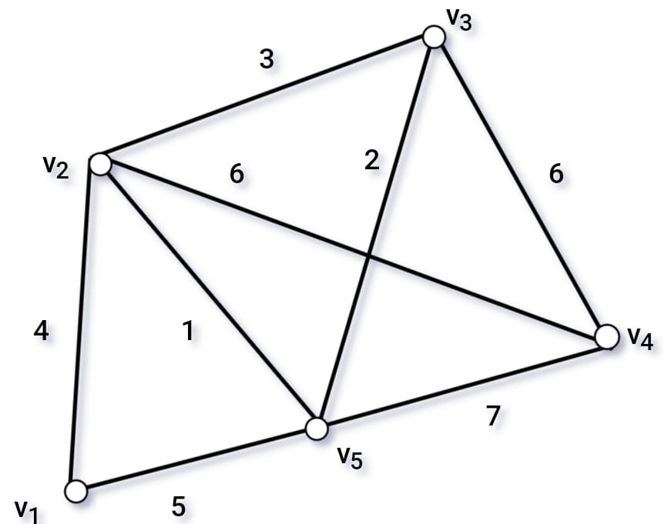
- Suppose you have three numbers. The sum of the two numbers and the twice of the second equals 2. The sum of the second and third when subtracted from the twice of first gives 1. The difference of thrice of first and five times the third gives 5. Rewrite the statement in form of the system of equations. Solve it using Matrix Method as an equation solver.

Section C
LONG ANSWERS (10 Marks each)
[Please answer Any Three questions in a separate page answer sheet especially provided for this purpose]

1. Solve the following questions
(a) Find the sum of odd integers from 1 to 2025.
(b) Find $a_{6}$ in the sequence defined by $a_{n}= 2a_{\left(n-1\right)} - a_{\left(n-2\right)}$ with $a_{0}=3$ and $a_{1}=4$.

2. Solve the following questions
(a) What are the Logic gates and construct the truth table of EX-NOR gate.
(b) If $p$ and $q$ are two statements show that $\sim \left(\sim p∧\sim q\right)=p∨qand\sim \left(\sim p∨\sim q\right)=p∧q$.

3. Solve the following questions
(a) Ten coins are tossed simultaneously. Find the probability of getting
(i) at least seven heads
(ii) exactly seven heads
(iii) at most seven heads.
(b) Find the inverse of $A$=$\left[\begin{matrix}1 & 1 & 1 \\ 0 & 2 & 3 \\ 5 & 5 & 1\end{matrix}\right]$ using elementary row operations.
4. Solve the following questions
- Convert the decimal number 285.68 to Binary Number system and Octal Number system.
- Convert following octal Numbers into its equivalent Decimal Number
- 36.45
- 0.5637
- 6543.2

